Setting up environment and first request to API
Authors (all rights reserved):
- Robert Barcik (robert@barcik.training)
- Jana Gecelovska

This guide will help you to set up your local Python development environment and send your first API request.

1. Setting up Python

To use the OpenAI Python library, you need to have Python installed on your computer. Visit the official Python website to download the latest version. Ensure you have at least Python 3.7.1 or newer to use the library effectively. You can verify Python installation by running:

python3 --version
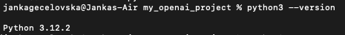

2. Creating a virtual environment

After installing Python, it's recommended to create a virtual environment to install the OpenAI Python library. Virtual environments provide an isolated space for your Python packages, preventing conflicts with libraries used in other projects.

- First, create a dedicated folder, for example, on your Desktop. Open terminal and navigate to Desktop using:
cd Desktop

- Create a new folder using the below prompt (change “folder_name” with your folder name):
mkdir folder_name

- Navigate to the newly created folder (change “folder_name” with your folder name):
cd folder_name

- Python includes the built-in venv module, which offers the necessary functionality to set up a virtual environment. Run the below command to create an environment called “openai_env”:
python3 -m venv openai_env

After creating the virtual environment, you need to activate it to start using it for your project.

On Windows, run the following command:
openai_env\Scripts\activate

On Unix or macOS, run the following command:
source openai_env/bin/activate

After activating the virtual environment, the prompt in your terminal should change, displaying (openai_env) to the left of the cursor input section. This indicates that the virtual environment is now active and ready for use:
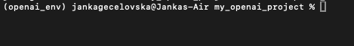

3. Installing the OpenAI Python library

Now, you can install the OpenAI Python library by running:

pip install --upgrade openai

Once the installation is complete, you can verify it by running pip list that will display all the Python libraries installed in your current environment. You should see the "openai" library listed there.
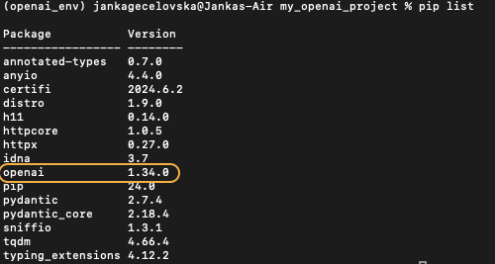

4. Setting up your OpenAI API key

To interact with the OpenAI API, you need to set up your API key. Go to the OpenAI Platform and sign up for an account, or log in if you already have one.

Navigate to account settings → Your profile → User API Keys. Click "Create new secret key". Please save this secret key somewhere safe and accessible. For security reasons, you won't be able to view it again through your OpenAI account. If you lose this secret key, you'll need to generate a new one.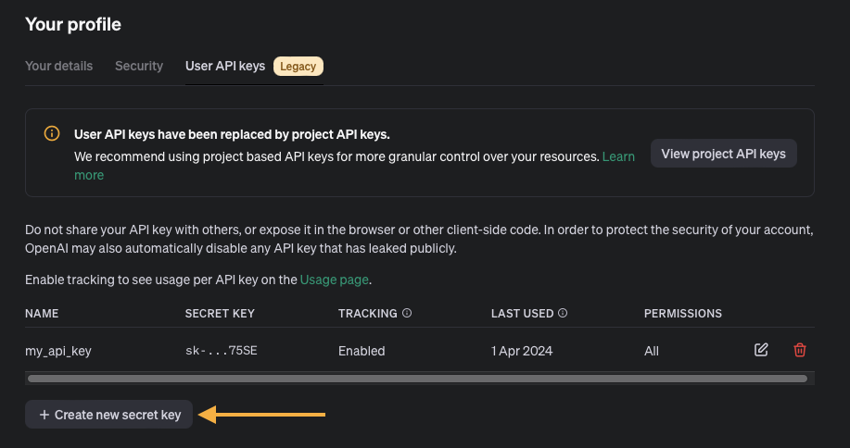

We will configure the API key to be accessible for all projects, making it easier for the Python library to automatically detect and use it without additional coding.

On MacOS
In the same terminal session where you activated the virtual environment, use command nano ~/.bash_profile or nano ~/.zshrc (for newer MacOS versions) to open the profile file in a text editor. Use the arrow keys to navigate to the end of the file (after <<<conda initialize>>>)
Note: Don't forget, maybe you will need sudo.
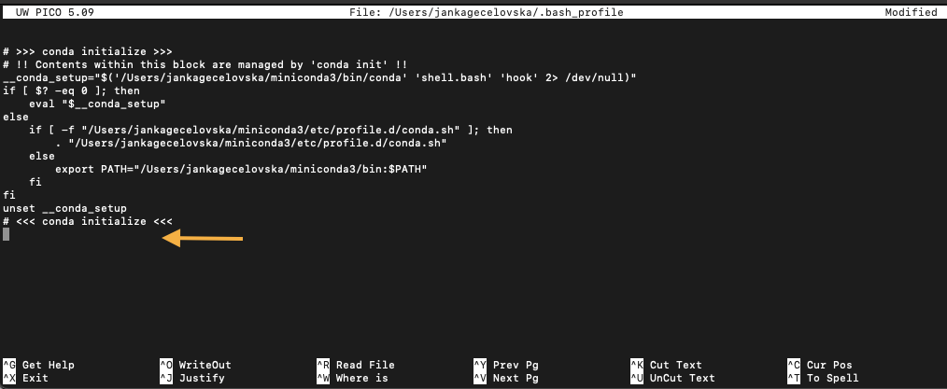

Now we set the API key as an environment variable. Add the following line, replacing “your-api-key-here” with your actual API key:

export OPENAI_API_KEY=”your-api-key-here”

Then save changes and exit the editor:
- Save Press Ctrl + O to write out the changes.
- Press Enter to confirm.
- Press Ctrl + X to exit the editor.

Use the command source ~/.bash_profile or source ~/.zshrc to load the updated profile.

Verify the setup by typing echo $OPENAI_API_KEY in the terminal. It should display your API key.

On Windows
Open Command Prompt and use the command below to set the environment variable in the current session. Replace “your-api-key-here” with your actual API key:

setx OPENAI_API_KEY "your-api-key-here"

To make the setup permanent, add the variable through the system properties as follows:
- Right-click on 'This PC' or 'My Computer' and select 'Properties'.
- Click on 'Advanced system settings'.
- Click the 'Environment Variables' button.
- In the 'System variables' section, click 'New...' and enter OPENAI_API_KEY as the variable name and your API key as the variable value.

To verify the setup, reopen the command prompt and type the command below. It should display your API key:

echo %OPENAI_API_KEY%

5. What is API?
An API (Application Programming Interface) is a set of rules that enables different software systems to communicate and share data. It defines how one application can request information or functionality from another, often across the internet. APIs allow developers to integrate third-party services into their applications without needing to know the internal workings of those services. For example, a social media app might use an API to fetch posts or user information from a remote server, or a payment gateway API might process transactions.

APIs often follow the HTTP (Hypertext Transfer Protocol) when used on the web, allowing applications to send and receive data over the internet. The two most common types of requests made to an API are GET and POST.

- A GET request is used to retrieve data from a server. For example, if you want to get the weather for a specific city, your application would send a GET request to a weather API, which would respond with the weather data.

- A POST request is used to send data to a server, often when creating new resources or submitting forms. For example, when submitting a login form on a website, a POST request sends your credentials to the server for authentication.

Other types of requests include PUT (to update a resource), DELETE (to delete a resource), and PATCH (to partially update a resource), but GET and POST are the most widely used in API interactions. This structured way of exchanging data allows developers to build powerful and connected applications efficiently.

6. Sending first API request

After configuring Python and setting up your API key, the next step is to send a request to the OpenAI API using the Python library. Follow these instructions:

Create a Python File: For example, you can use a Jupyter notebook. First, install Jupyter by executing command jupyter in the same terminal session where you activated the virtual environment. Once the installation is complete, type jupyter notebook:

It should open a new browser window with the Jupyter home screen. Create a Python file by clicking in “New”
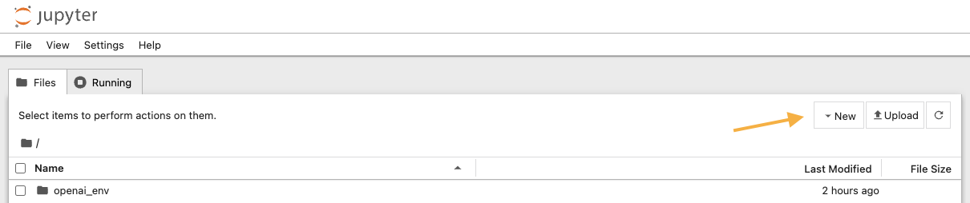

Open the file and paste the code into it, which sends a request to the API:

from openai import OpenAI
import os

# Assuming OPENAI_API_KEY is set as an environment variable
api_key = os.getenv("OPENAI_API_KEY")
client = OpenAI(api_key=api_key)

# Request to OpenAI API
response = client.chat.completions.create(
model="gpt-3.5-turbo",
messages=[
{"role": "system", "content": "You are a creative assistant who writes engaging and educational poems."},
{"role": "user", "content": "Compose a poem that explains what the OpenAI API is and how it can be used."}
]
)

To print the response, paste this code into notebook:

# Print the response
response.choices[0].message.content.replace('\n', ' ')

